North Lawndale College Prep HS
Freshman Project: Mini-Unit

Name: ________________________________________________________________

Based on the texts that you have discussed and analyzed in class, what is an ingredient to a successful school?

USE COMPLETE SENTENCES BELOW.

I. Introduction:
Mini-Unit Driving Question (DQ): Is nutrition important for student success?

Hypothesis: Answer the driving question stating your opinion on how students can be more successful, giving a reason why you think this is true.
______________________________________________________________________________
______________________________________________________________________________
______________________________________________________________________________
______________________________________________________________________________

Claim: What do you know?
______________________________________________________________________________ ______________________________________________________________________________
Evidence: How do you know that?
According to (name author, year)… followed by the pattern of IV affecting DV.
______________________________________________________________________________
______________________________________________________________________________
______________________________________________________________________________

Evidence (cont.): How do you know that?
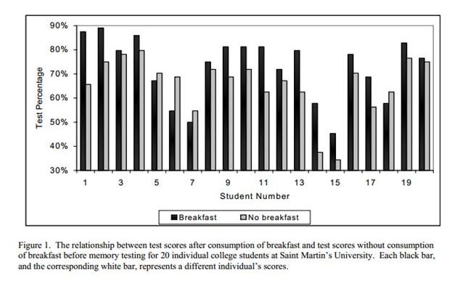
As can be seen from Figure 1/ As indicated by Figure 1/ Figure 1 shows;… FINISH THIS SECTION USING THE DATA TO SUPPORT YOUR CLAIM. YOU MUST INCLUDE AT LEAST ONE DATA POINT!
______________________________________________________________________________
______________________________________________________________________________
______________________________________________________________________________
______________________________________________________________________________
______________________________________________________________________________
Reasoning: Why does the evidence support your claim?
Obviously/ Surely/ Most likely/ if…then…because... STATE WHY THE STUDENT LEARNING IMPROVES…GIVE A REASON.
______________________________________________________________________________
______________________________________________________________________________
______________________________________________________________________________
______________________________________________________________________________
______________________________________________________________________________

Claim: What do you know?
______________________________________________________________________________ ______________________________________________________________________________
Evidence: How do you know that?
According to (name author, year)… followed by the pattern of IV affecting DV.
______________________________________________________________________________
______________________________________________________________________________
______________________________________________________________________________
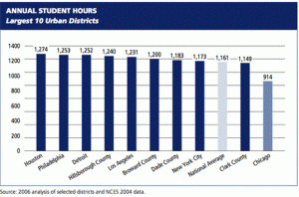
Figure 2
As can be seen from Figure 2/ As indicated by Figure 2/ Figure 2 shows;… FINISH THIS SECTION USING THE DATA TO SUPPORT YOUR CLAIM. YOU MUST INCLUDE AT LEAST ONE DATA POINT!
______________________________________________________________________________
______________________________________________________________________________
______________________________________________________________________________
______________________________________________________________________________
______________________________________________________________________________

Reasoning: Why does the evidence support your claim?
Obviously/ Surely/ Most likely/ if…then…because... STATE WHY THE STUDENT LEARNING IMPROVES…GIVE A REASON.
______________________________________________________________________________
______________________________________________________________________________
______________________________________________________________________________
______________________________________________________________________________
______________________________________________________________________________
______________________________________________________________________________

Claim: What do you know?
______________________________________________________________________________ ______________________________________________________________________________
Evidence: How do you know that?
According to (name author, year)… followed by the pattern of IV affecting DV.
______________________________________________________________________________
______________________________________________________________________________
______________________________________________________________________________
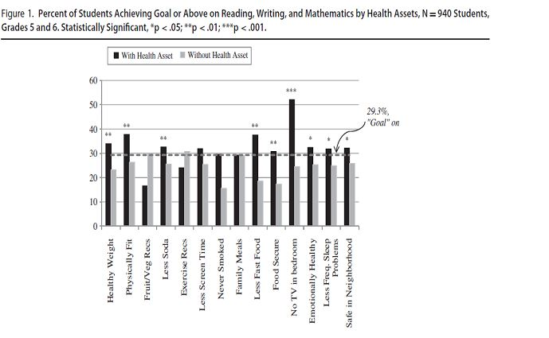
As can be seen from Figure 1/ As indicated by Figure 1/ Figure 1 shows;… FINISH THIS SECTION USING THE DATA TO SUPPORT YOUR CLAIM. YOU MUST INCLUDE AT LEAST ONE DATA POINT!
______________________________________________________________________________
______________________________________________________________________________
______________________________________________________________________________
______________________________________________________________________________
______________________________________________________________________________
Reasoning: Why does the evidence support your claim?
Obviously/ Surely/ Most likely/ if…then…because... STATE WHY THE STUDENT LEARNING IMPROVES…GIVE A REASON.
______________________________________________________________________________
______________________________________________________________________________
______________________________________________________________________________
______________________________________________________________________________
Conclusion: Summarize your argument by restating your opinion on what are some ways to improve student learning.
______________________________________________________________________________
______________________________________________________________________________
______________________________________________________________________________
______________________________________________________________________________
______________________________________________________________________________
______________________________________________________________________________
______________________________________________________________________________
______________________________________________________________________________
______________________________________________________________________________
______________________________________________________________________________
______________________________________________________________________________

