Estimating the Impact of the DREAM Act

Adapted from: “Estimating the impact of the DREAM Act,” Center for Immigration Studies, November 2010, author: Steven A. Camarota http://www.cis.org/dream-act-cost

PURPOSE: This Memorandum examines the costs and likely impact of the DREAM Act currently being considered by Congress. The act offers permanent legal status to illegal immigrants up to age 35 who arrived in the United States before age 16 provided they complete two years of college. Under the act, beneficiaries would receive in-state tuition. Given the low income of illegal immigrants, most can be expected to attend state schools, with a cost to taxpayers in the billions of dollars. As both government funds for education and enrollment spaces are limited at state universities and community colleges, the act may reduce the educational opportunities available to U.S. citizens.

METHOD AND DATA: When estimating the immediate costs of the DREAM Act, there are two key issues that have to be resolved. First, how many illegal immigrants are potentially eligible. Second, how many would come forward and enroll in college? The Migration Policy Institute used the files of the Current Population Survey to estimate a total of 2.15 million persons who might qualify for the DREAM Act.

Number of Potential Beneficiaries: Our analysis of the 2009 and 2010 Current Population Survey estimates the number of potentially eligible illegal immigrants who meet the age and residency requirements to be around 1.998 million. Of those who meet the age and residency requirement, 43 percent (859,000) are under age 18 and 57 percent (1.139 million) are adults. Of the 1.139 million adults who could potentially benefit from the DREAM act, 5 percent (100,000) have already completed two years of college. Of the remaining 1.039 million adults, we estimate that 51 percent (530,000) have graduated high school.

Number Who Will Enroll in College: There is no way to know for certain what fraction of illegal immigrants who meet or will meet the DREAM Act’s age and residency will come forward and enroll in college. We think it likely that 95 percent (1.203 million) of the 1.266 million illegal immigrants who could qualify will eventually come forward to register for provisional legal status under the DREAM Act. Of the 1.203 million high school graduates who will come forward, we assume 50,000 will enroll in the military, which leaves 1.038 million potential new college students.

Impact on Tax Payer: To estimate the cost to taxpayers of 1.038 million new students, we use the 10 states with the largest illegal immigrant populations as reported by the Department of Homeland Security. Table 1 shows the average difference between in-state and out-of-state tuition at state universities and community colleges for one year of full-time tuition in the top states of illegal immigrant settlement. The average per-year cost for the enrolled illegal immigrant students would be $5,970. This individual cost combined with our estimate of 1.038 million new students enrolled colleges and universities would create a total cost of $6.2 billion a year for each year these students are enrolled, assuming the current fee structure.

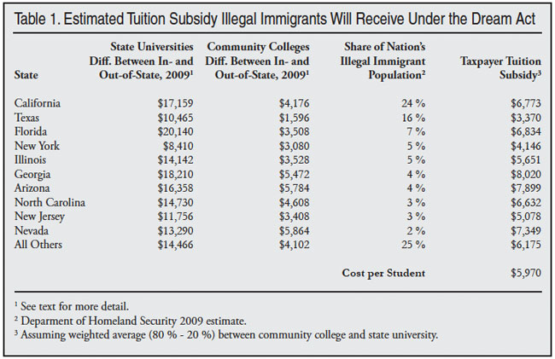

Impact on American Students: The DREAM Act does not provide funding to states and counties to cover the costs it imposes. Since enrollment and funding are limited at public institutions, the act’s passage will require some combination of tuition increases, tax increases to expand enrollment, or a reduction in spaces available for American citizens at these schools.

Tuition hikes will be particularly difficult for students, as many Americans already find it difficult to pay for college. Research indicates that one out of three college students drop out before receiving a degree. Costs are a major reason for the high dropout rate.

Providing state schools with added financial support to offset the costs of the DREAM Act would avoid the fiscal costs at the state and local level, but it would shift the costs to federal taxpayers.

Lawmakers need to consider the strains the DREAM Act will create and the impact of adding roughly one million students to state universities and community colleges on the educational opportunities available to American citizens.

OPPOSITION: Advocates of the DREAM Act argue that it will significantly increase tax revenue, because with a college education, recipients will earn more and pay more in taxes over their lifetime.

REBUTTAL:

Any hoped-for tax benefit is in the long-term, and will not help public institutions deal with the large influx of new students the act creates in the short-term.

Given limited spaces at public institutions, there will almost certainly be some crowding out of U.S. citizens ─ reducing their lifetime earnings and tax payments.

The DREAM Act only requires two years of college; no degree is necessary. The income gains for having some college, but no degree, are modest.

Because college dropout rates are high, many illegal immigrants who enroll at public institutions will not complete the two years the act requires, so taxpayers will bear the expense without a long-term benefit.

