Here are some tips to make sure that you SAVE your Weekly Reflection so that you do not have to start all over!
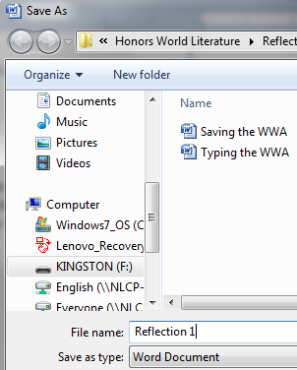
Flash Drive
- On the top LEFT corner, click the Circle.
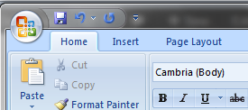
- Click “Save As”
- Choose your Flash Drive in the “Save As” Dialog Box.
- Type a “File Name”: Reflection 1
- Save “Type” as Rich Text Format
- Click “Save”

Desktop
- On the top LEFT corner, click the Circle (see Flash Drive directions)
- Click “Save As”
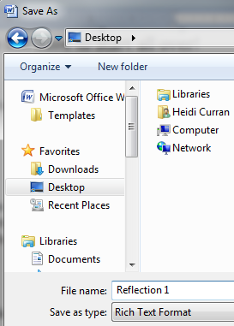
- Choose “Desktop”
- Type a “File Name”: Reflection 1
- Save “Type” as Rich Text Format
- Click “Save”

Email
- Log in to your email account.
- Create a new email (Click “Compose”)
- Type your email address where it says “To:”
- Subject: Reflection 1
- Click the icon that looks like a paperclip or
says “Attach”
- Find your file.
- Double click your file.
- After it uploads, click send.

