Here are some tips to make sure that your Weekly Reflection looks EXACTLY like the example that I gave you:

Heading:
1. How do I make the heading single-spaced?
- Step 1: In the “Styles” box, choose “No Spacing”
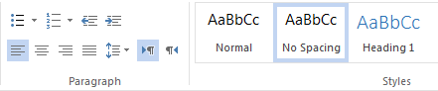
- Step 1: Highlight the entire heading.
- Step 2: Click the “Line Spacing Options” button:
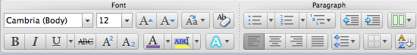
- Step 3: Choose 1.0
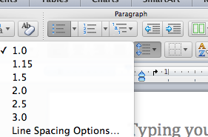

Title:
How do I center my title? Click the “Center Align” button. Make sure your title is creative!

Double Space:
How do I double space my document?
Use this shortcut:
- Step 1: Highlight everything except your heading.
- Step 2: AT THE SAME TIME…type “CONTROL” and “2”
- If the words disappear, calm down. Click “Undo”, and try again. You probably didn’t press “CONTROL” and “2” at the SAME TIME.

Font:
How do I turn the font to “Times New Roman” and 12?
- Choose Times New Roman from the Font box.
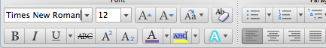
- Choose 12 from the Font Size box.

Fill the page with your THOUGHTS not spaces or large font.

Do NOT use a different font size.
Do NOT put more than one space after the heading, title, or between paragraphs.
Do NOT make your title larger than size 12.
Do NOT go over one page!

You will get a 0 if you do this.

